logoFCT_horiz.pdf

**Interacção Pessoa-Máquina**

**2020/2021**

**TMASK**

Stage 3: 1st prototype

**Realizado por: Lab class Nº** P2

41936, Samuel Robalo **Group Nº 13**

44592, Alexander Denisov

50654, Francisco Silva **Professor:**

51095, Daniel Dias Teresa Romão

October 28, 2020

**Sketches and storyboard**

Below are some of the project’s initial sketches.

They can be viewed with more detail on the team’s website: [Tactical Design](https://denisov93.github.io/tacticaldesign/).

|  |  |
| --- | --- |
|  |  |
|  |  |

**Prototype photos and link**

[Prototype](https://marvelapp.com/prototype/52a1hd0) – Press the “G” key to view all screens and select a scenario.

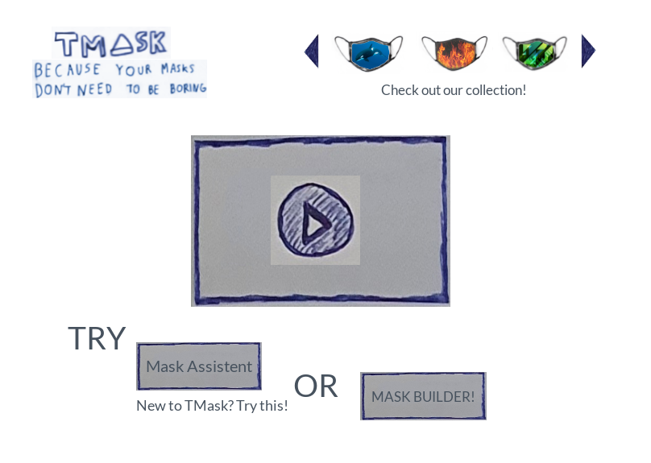

Figure : Landing Page

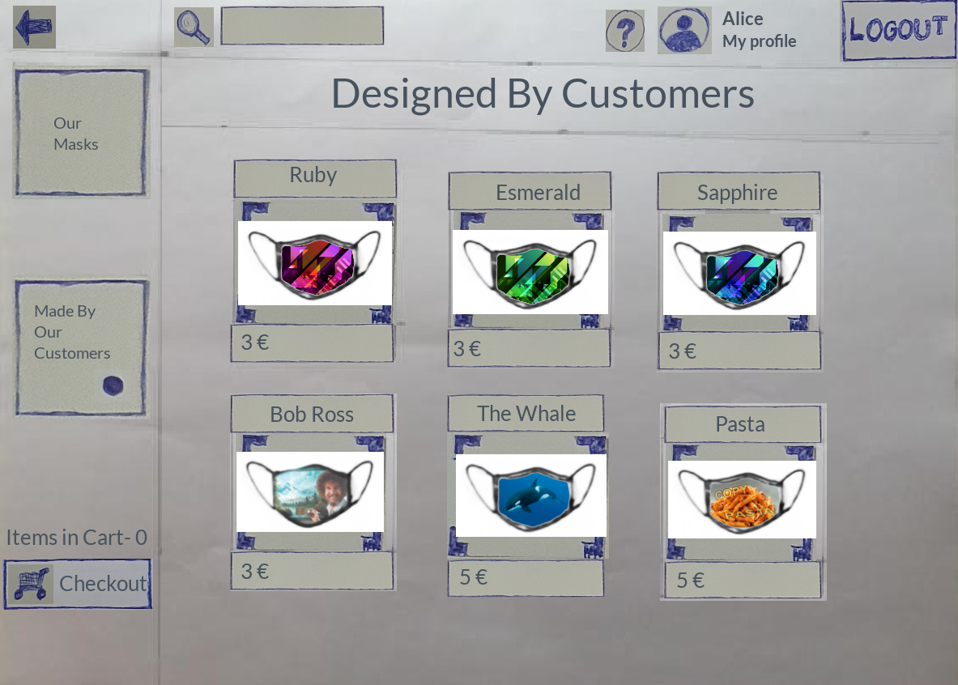

Figure : Catalog

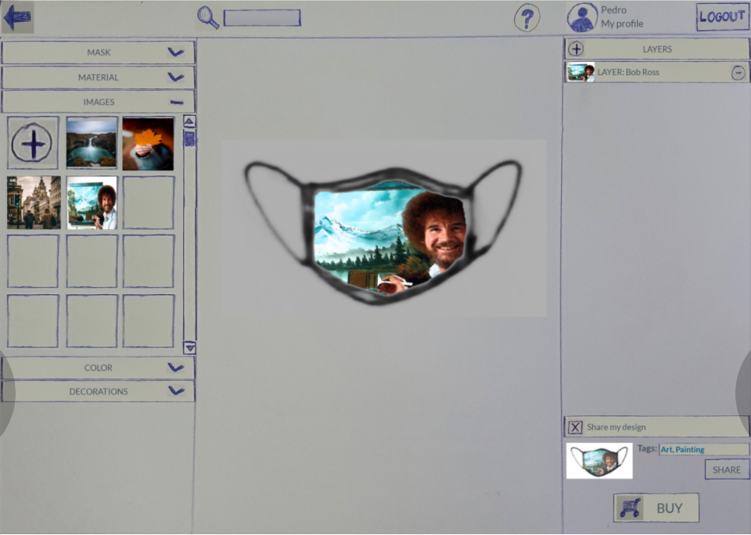

Figure : Mask Builder

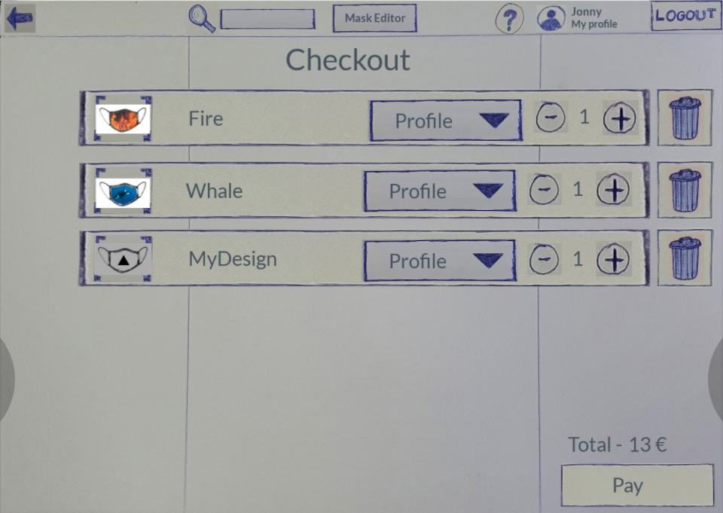

Figure : Shopping Cart

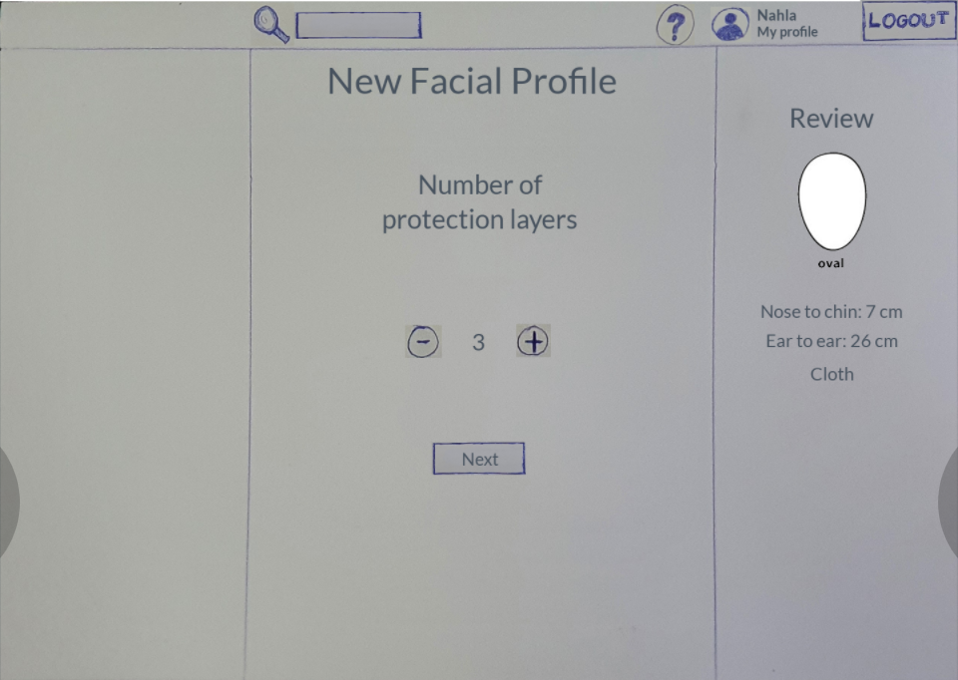

Figure : Facial Profile Creation

**Briefing**

The website is called TMask design being planned by TacticalDesign (IPM Group13 of P2 Shift).

At the core focus this web application allows the user to create personalized masks with an editor, has an account system, that allows multiple profiles per account, a mask catalog with default masks by TMask and shopping cart to view items before buying them.

The ideia is that these masks catch the eyes of people walking around or give a feel of a fashionable item.

**Scenarios**

Scenario #1 - Find a matching mask for a dress

Alicia had a beautiful pink dress with strass to wear to the ball.

But, due to COVID, she should always wear a mask whenshe goes outside.

She looked in her house and found only ugly "medical green" masks.

She decided to browse online on a useful website that she already had an account and searched for a matching mask. She chose the mask “Simple Pink”, selected the facial profile “Alice”, and bought it.

Scenario #2 – Share your Art

Pedro, a local artist, was looking for a way to share his art and express himself. But, due to COVID, there is no way to display it in the gallery or in the usual way.

So, to show his paintings, he went to the website that Alicia recommended him. He opened the mask builder, uploaded one of his pictures, adjusted it to its fit and shared them with his audience by the tags “art, painting”.

Scenario #3 – Jonny spend too much on masks

Jonny is very afraid catch COVID, so he always uses a mask!

Luckily for Jonny, he found a nice website with masks in different shapes and colours. He chose some masks (“Fire” and “The Whale”) and even designed one himself (a mask with a triangle in the center). He put all of them on the shopping list, but later found out he was about to buy too much. So, he checked what he was buying, removing all but the one he designed. (He did not finish the purchase.)

Scenario #4 – Create a facial profile

Nahla just logged in and is using the website for the first time. She decides to create a facial profile. Proceeds to take her measurements and introduces the data on the forms. Nahla has an oval face, 7cm from the bridge of her nose to just under her chin and 26cm between her ears, passing through the chin. Picks the "Cloth" type and format of the mask, selects 3 protection layers and saves the profile under the name of “Custom profile”.

**Observation**

//TODO